**Heritage Institute of Technology, Kolkata**



**CERTIFICATE**

This is to certify that the project entitled "Electric Field Calculation in High Voltage Systems using CSM method" has been submitted to the department of Electrical Engineering, Heritage Institute of Technology, Kolkata for the fulfilment of the requirement for the award of the degree of Bachelor of Technology in "Electrical Engineering" by following student of final year B.Tech. (Electrical Engineering).

**Student Name (with Roll no.)**

|  |  |
| --- | --- |
| Kazi Masudur Rahaman | 1759002 |
| Diptarup Chakraborty | 1759003 |
| Shruti | 1759047 |
| Ajay Yadav | 1759041 |
| Niraj Kumar | 1759013 |
| Karan Sagar | 1759060 |

|  |  |
| --- | --- |
| Prof. Sanjay Chandra Das  (Project Guide) | Prof. Saibal Dutta  (Head of Department) |

**Declaration**

We, hereby declare that the discussion entitled “Electric Field Calculation in High Voltage Systems using CSM method” being submitted by us towards the partial fulfilment of the degree of Bachelor of Technology, in the Department of Electrical Engineering is a project work carried by us under the supervision of Prof. Sanjay Chandra Das, and have not been submitted anywhere else.

We will be solely responsible if any kind of plagiarism is found.

Date:

|  |  |
| --- | --- |
| Kazi Masudur Rahaman | Diptarup Chakraborty |
| Shruti | Ajay Yadav |
| Niraj Kumar | Karan Sagar |

**Acknowledgement**

We would like to share our sincere gratitude to all those who helped us in completion of this project. During the work we faced many challenges due to our lack of knowledge and experience, but these people helped us to get over from all the difficulties and in final completion of our idea to a shaped sculpture.

We would like to thank our mentor, Prof. Sanjay Chandra Das Sir for his governance and guidance, because of which our whole team was able to learn the minute aspects of a project work.

All of our team is thankful to all the Faculties and Staff of Department of Electrical Engineering, HITK, for their help and support towards this project and our team.

In the last we would like to thank the management of Heritage Institute of Technology, Kolkata for providing us such an opportunity to learn from these experiences.

We are also thankful to our whole class and most of all to our parents who have inspired us to face all the challenges and win all the hurdles in life.

|  |  |
| --- | --- |
| **Kazi Masudur Rahaman** | **1759002** |
| **Diptarup Chakraborty** | **1759003** |
| **Shruti** | **1759047** |
| **Ajay Yadav** | **1759041** |
| **Niraj Kumar** | **1759013** |
| **Karan Sagar** | **1759060** |

**Contents**

* Introduction
* Charge Simulation Method
* Basic Principle
* CSM in multi-dielectric media
* Programming Logic
* Conclusion
* References

**Introduction**

In the insulation design of any high voltage system, a complete knowledge of the electric field distribution is essential for estimating the insulating ability of the system. For a simple physical system, it is usually possible to find an analytical solution. However, in many cases the physical systems are so complex that it is extremely difficult, if not impossible, to find analytical solutions. Hence, in such cases numerical methods are employed for electric field calculations. The existing numerical methods include the Finite Difference Method (FDM), the Finite Element Method (FEM), the Monte Carlo Method (MCM), the charge simulation Method (CSM), the Integral Equation Method (TEM) and the Boundary Element Method (BEM). The IEM is often called the Surface Charge Simulation Method (SCSM).

**Charge Simulation Method**

The principle of FDM and FEM is to provide the entire region under study into a large number of sub-regions, and solve for unknown potentials a set of coupled simultaneous linear equations which approximate Laplace's or Poisson's equation. In MCM Laplace's equation is solved for an unknown potential of any point as the expected magnitude of the boundary value at the intersection of the simulated random walks starting from the point and the boundary.

Compared with these three methods, only boundary surfaces, i.e., electrode surfaces and dielectric interfaces, are subdivided and boundary charges or charge densities are taken as unknowns in CSM and IEM. It follows, firstly, that the amount of human time and effort needed for subdivision is greatly reduced in CSM and IEM. Secondly, the electric field strength can be given explicitly in CSM and IEM without any numerical differentiation of the potential, which results in significant errors. The second characteristic is very important because the field strength is usually more important for the design of an insulating system than the potential.

As compared to IEM, CSM has the following **advantages**.

i) CSM is generally more accurate than IEM owing to the smooth simulation of a curved surface with an equipotential surface. By IEM, on the other hand, the approximation of an electrode surface with straight line segments results in considerable error especially near the surface.

ii) CSM needs not consider singularities which may take place when the potential or the field intensity due to a subsurface charge is computed on the identical subsurface by point matching.)

iii) CSM requires no or very little numerical integration in constructing the coefficient matrix for unknown charges and then in obtaining the field intensity. This makes the programming easier and the computation faster than by IEM.

CSM has a **disadvantage** in that the electric field including very thin electrodes is difficult to calculate because fictitious charges approximating the field must be placed inside the electrodes.

However, CSM is very successful in most of the high voltage field problems. It is very simple and applicable to systems having more than one dielectric medium. This method is also very suitable for 3 - D fields with or without symmetry.

**Basic Principle**

The basic principle of conventional CSM is very simple. For the calculation of electric fields, the distributed charges on the surface of the electrode are replaced by N number of fictitious charges placed inside the electrode. The types and positions of these fictitious charge are predetermined but their magnitudes are unknown. In order to determine their magnitude some contour points are selected on the surface of electrode. In the conventional CSM the number of contour points is selected equal to the number of fictitious charges. Then it is required that at any one of these contour points the potential resulting from superposition of all the fictitious charges is equal to the known electrode potential. Let, Q be the jth fictitious charge and V be the known potential of the electrode. Then according to the superposition principle

$$\sum_{j=1}^{N}{P_{ij}Q_{j}=V}$$

----(1)

where $P_{ij}$ is the potential coefficient which can be evaluated analytically for different types of fictitious charges by solving Laplace's equation.

When Eqn. (1) is applied to N contour points, it leads to the following system of N linear equations for N unknown fictitious charges.

[P]N×N [Q]N = [V]N ---(2)  _ ____

where [P] = potential coefficient matrix, [Q] = column vector of known potential of contour points.

The Eqn. (2) is solved for the unknown fictitious charges. As soon as the required charge system is determined, the potential and the field intensity at any point, outside the electrodes can be calculated. While the potential is found by Eqn. (1), the electric stresses are calculated by superposition of all the stress vector components. For example, for Cartesian co-ordinate system, the three superimposed field components at any point i are given as follows.

$$E_{x,i}=-\sum_{j=1}^{N}{\frac{∂P_{ij}Q_{j}}{∂x}=}-\sum_{j=1}^{N}{F_{x,ij}Q_{j}}$$

----(3)

$$E_{y,i}=-\sum_{j=1}^{N}{\frac{∂P_{ij}Q_{j}}{∂y}=}-\sum_{j=1}^{N}{F_{y,ij}Q_{j}}$$

----(4)

and

$$E_{z,i}=-\sum_{j=1}^{N}{\frac{∂P_{ij}Q_{j}}{∂z}=}-\sum_{j=1}^{N}{F_{z,ij}Q_{j}}$$

----(5)

where $F_{x,ij}$, $F_{y,ij}$ and $F_{z,ij}$ are the field coefficients in the x, y and z directions respectively.

In many cases the effect of the ground plane is to be considered for electric field calculation. This plane can be taken into account by the introduction of image charge if floating electrodes are present whose potentials are uniform but unknown. Eqn. (2) is modified to include the supplementary condition that the sum of inner charges on each floating electrode is zero. If the floating electrode has a net charge, the sum of its inner charges is equal to the known net charge value.

**CSM In Multi-dielectric Media**

The field computations for a multi dielectric-insulating system are somewhat complicated due to the fact that the dipoles are realigned in dielectric media under the influence of the applied voltage. Such realignment of dipoles produces a net surface charge on the dielectric interface. Thus, in addition to the electrodes, each dielectric interface needs to be simulated by fictitious charges. Here. it is important to note that the dielectric boundary does not correspond to an equipotential surface. Moreover, it must be possible to calculate the electric field on both sides of the dielectric boundary.

In the simple example shown in fig. there are N1 number of charges and contour points to simulate the electrode, of which NA are on the side of dielectric A and (N1- NA) are on the side of dielectric B. These N1 charges are valid for field calculation in both dielectrics. At the dielectric interface there are N2 contour points (N1+1,...,N1+N2) with N2 charges ( N1+1,..., N1+N2) in dielectric A valid for dielectric B and N2 charges (N1+N2+1,...,N1+2N2) in dielectric B valid for dielectric A. Altogether there are (N1+N2) number of contour points and (N1+ 2N2) number of charges.

In order to determine the fictitious charges, a system of equations is formulated by imposing the following boundary conditions:

1. At each contour point on the electrode surface the potential must be equal

to the known electrode potential. This condition is also known as Dirichlet's condition on the electrode surface.

1. At each contour point on the dielectric interface, the potential and the

normal component of flux density must be same when computed from

either side of the boundary.

1. Thus, the application of the first boundary condition to contour points 1 to N1 yields the following equations:

$$\sum_{j=1}^{N_{1}}{P_{ij}Q_{j} +\sum_{j=N_{1}+N_{2}+1}^{N_{1}+{2N}_{2}}{P_{ij}Q_{j} }=V}$$

i=1,NA ----(6)

And

i=NA+1,N1 ----(7)

Again, the application of the second boundary condition for potential and normal

flux density to contour points = N1+l to N1+N2 on the dielectric interface results into the following equations from potential continuity condition:

i=N1+1,N1+N2 ----(8)

From continuity condition of normal flux density Dn:

DnA (i)-DnB (i) = 0 ----(9)

for i=N1+1, N1+N2

Eqn. (9) can be expanded as follows:

i=N1+1,N1+N2 ----(10)

where $F_{n,ij}$ is the field coefficient in the normal direction to the dielectric boundary at the respective contour point and $ε_{A}$& $ε_{B}$ are the permittivities of dielectric A and B respectively. Eqns. (4) to (10) are solved to determine the unknown fictitious charges.

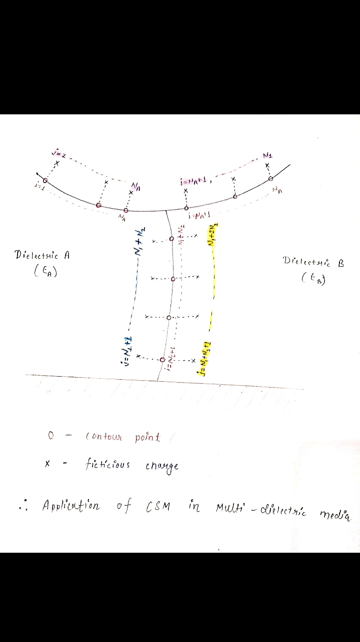

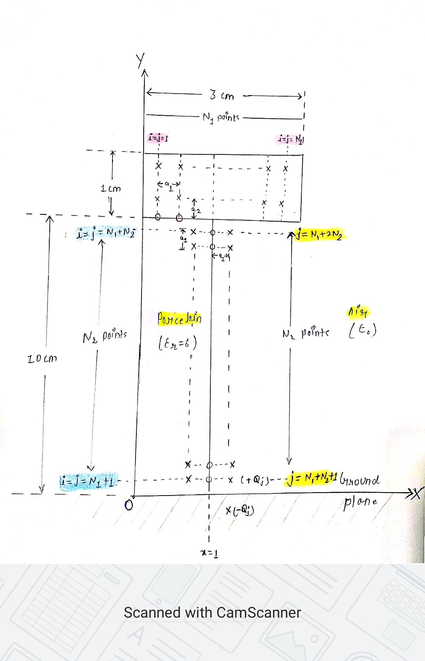

Insulator model used for demonstrating CSM

**Programming Logic**

In the demonstration here, x-axis represents grounded plane. j th charge ($Q_{j}$) present at (xj, yj, zj) will thus, have an image charge (- $Q_{j}$) due to this grounded plane at (xj, -yj, zj). The combined effective voltage(v) at i th contour point (situated at xi, yi, zi) due to $Q_{j}$ and its image charge will be given by

**v=(1/(4 $×$** **pi $×$** **e)) $×$** **(1/r1-1/r2) $× Q_{j}$** **= $P_{ij} ×$ $Q_{j}$** ,

where r1 and r2 are distances between i th contour point and $Q_{j}$ and its image charge respectively, given by

**r1=sqrt((xi-xj)^2+(yi-yj)^2+(zi-zj)^2)** and **r2=sqrt((xi-xj)^2+(yi+yj)^2+(zi-zj)^2) .**

e is permittivity of space, as applicable.

Since, $E_{n,i}=-\sum_{j=1}^{N}{\frac{∂P_{ij}Q_{j}}{∂n}=}-\sum_{j=1}^{N}{F_{n,ij}Q_{j}}$, $F_{n,ij}$ at dielectric interface x=1, is calculated as

$F_{x,ij}$**=((xi-xj)/(4 $×$** **pi $×$** **e))*((1/((r1)^3))-(1/((r2)^3))) $×$ $Q_{j}$** .

**Note:** Since the chosen electrode arrangement is 2D, axial symmetric, the above steps can be carried out only for one half area of the structure and the obtained results will be replicated for the other half.

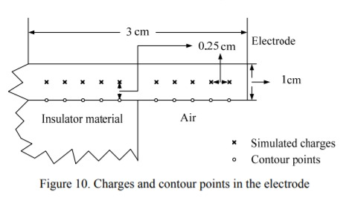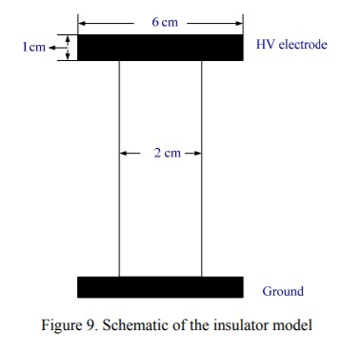

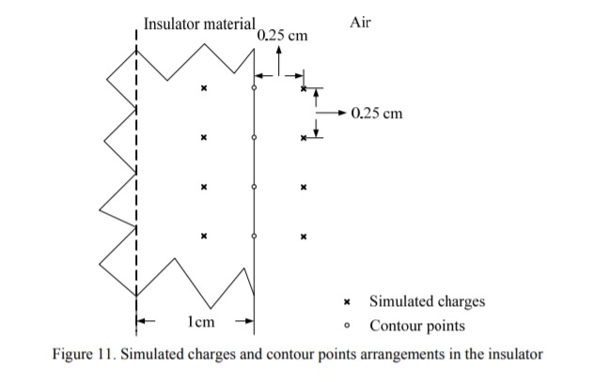

1.Using the 𝑃ij and 𝐹n,ij values calculated for each 𝑄j, its image charge and ith contour point, the P matrix is filled.

2.On solving the matrix equation 𝑄=P-1 𝑉, we find all the fictitious discrete charges.

**Accuracy criteria:**

1.Using the calculated Q matrix, we find voltages at some points on electrode boundary, other than the contour points, and calculate the percentage deviation of this voltage from the known electrode voltage. This gives ***error in electrode potential***.

2.We then calculate potential at some points, other than the contour points, on dielectric boundary, from both sides and calculate the difference. This difference is called ***potential discrepancy***.

3.The percentage deviation in step 3 and absolute potential discrepancy in step 4 need to be close to zero for accurate simulation. This is achieved by decreasing distance between consecutive charges, i.e., by increasing number of charges, such that f=a2/a1 increases, where a2 is distance between 𝑄j and corresponding contour point and a1 is distance between consecutive charges.

*Note:*

* For simplicity of the P and Q matrices, each jth charge in Q matrix from j=1 to N, considers the combined effect of two exactly oppositely placed charges on upper and lower sides of the electrode. Thus 2×N1 electrode charges are represented by N1 charges in Q matrix. Also, the corresponding $P_{ij}$ and $F_{n,ij}$ values are sum of potential coefficients and electric field coefficients respectively, for two oppositely placed electrode charges.
* While calculating potential or electric field at any point due to an electrode charge given by the program, i.e., each jth charge in calculated Q matrix from j=1 to N, the corresponding potential coefficient or electric field coefficient should also be sum of potential coefficients and electric field coefficients respectively, for two oppositely placed electrode charges.

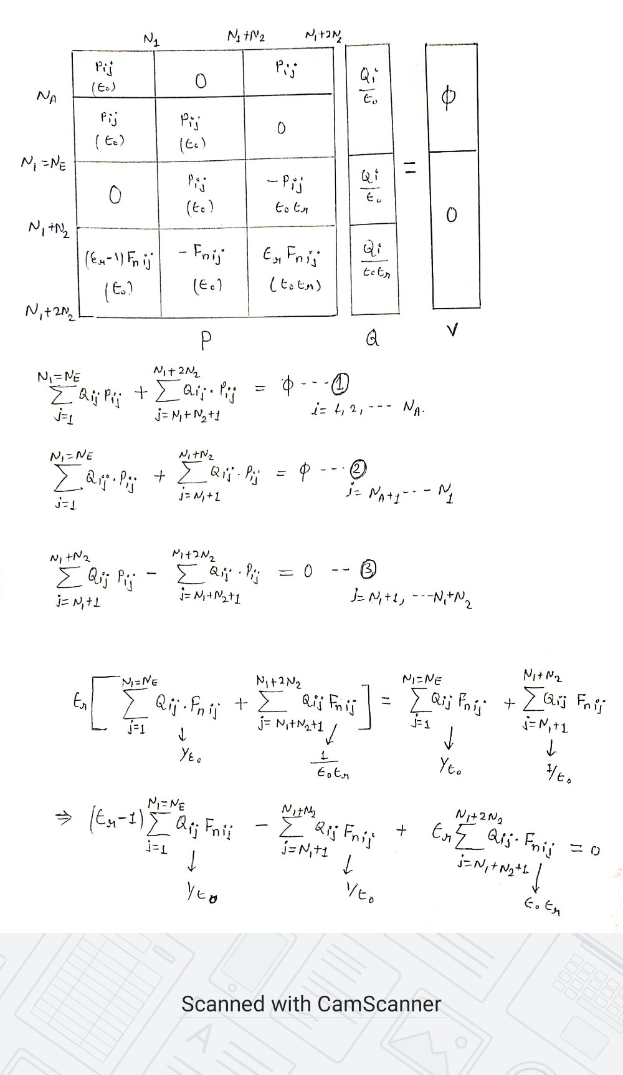

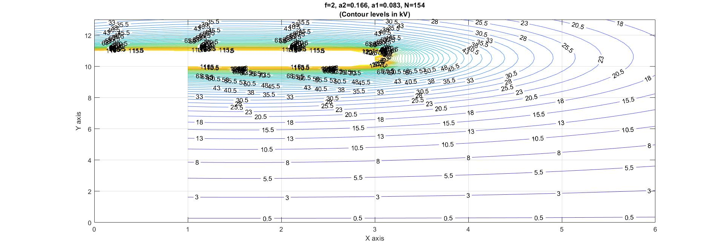

Equipotential lines simulated around insulator model

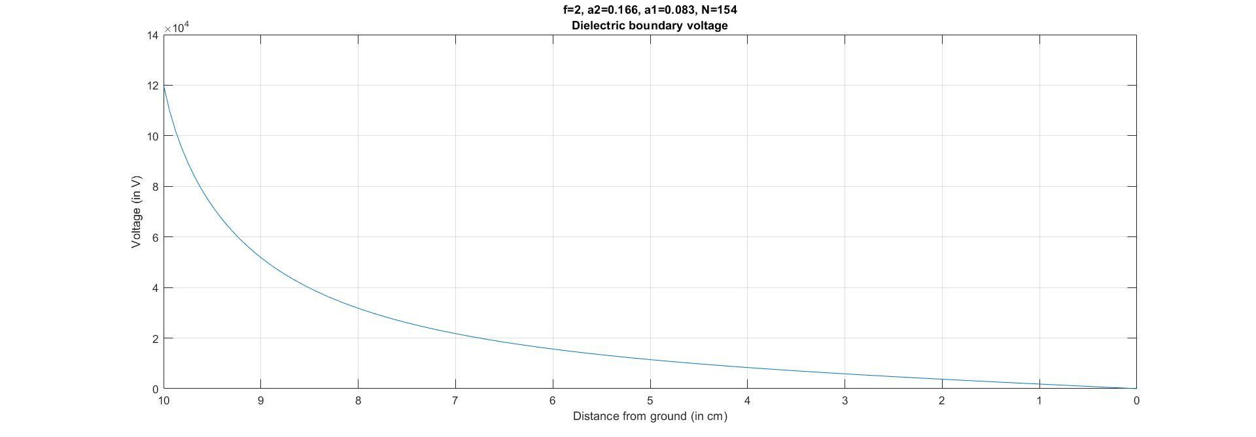Voltage at dielectric boundary between insulator and air

|  |  |  |  |
| --- | --- | --- | --- |
| **f value** | | **RMS Electrode Potential error** | **RMS Potential discrepancy** |
| **(in %)** | **(absolute)** |
| **f=0.5** | a2=0.125, a1=0.25 | 8.374178337 | 1.37721E-12 |
| N=50 |
| **f=1** | a2=a1=0.167 | 3.006505257 | 1.95109E-12 |
| N=76 |
| **f=1.5** | a2=0.1875, a1=0.125 | 1.434459549 | 7.64E-12 |
| N=102 |
| **f=2** | a2=0.166, a1=0.083 | 0.687046766 | 4.91219E-12 |
| N=154 |
| **f=3** | a2=0.1875, a1=0.0625 | 0.294091435 | 9.43044E-12 |
| N=206 |
| **f=4** | a2=0.2, a1=0.05 | 0.232924014 | 1.13699E-11 |
| N=258 |

**Conclusion**

As shown in this project the charge simulation method is a suitable way for the solution of many electric practical field problems. The presented application of this method in our project gives an idea of the variety of the possible applications of this method.

* The CSM method produces an accurate enough estimation of charge system to satisfy boundary conditions, using simple and small number of equations.
* For multi-dielectric system, CSM can be the preferred choice, as initial input boundary equations are easy to form under discrete charges.
* Verification of the simulated charge system at arbitrary points also becomes easier due to discrete charges.
* Increasing number of charges or decreasing distance between consecutive charges greatly reduces errors, but also decreases computational efficiencies. In the simulated results, an f value above 1 and upto 2 produces acceptable errors but any value above that produces negligible decrease in error and instead increases mathematical complexity massively.
* The method can be made faster and more efficient by using genetic algorithm to determine the location and type (point, line or ring) of charges.

**References**

1. IEEE Transaction papers: [www.ieee.org](http://www.ieee.org/) , [https://sci-hub.se](https://sci-hub.se/)
2. Wang Erzhi, Han Changwei, Liu Xiaoming and Cao Yundong. ELECTRIC FIELD CALCULATION FOR VACUUM INTERRUPTER BY OPTIMIZED CHARGE SIMULATION METHOD. XXIInd Int. Symposium on Discharges and Electrical Insulation in Vacuum-Matsue-2006
3. Xiaoming Lid, Yundong Cao, Enhi Wang, Li Jin. CALCULATION OF ELECTRIC FIELD IN VACUUM CIRCUIT-BREAKER USING-OPTIMIZED AND TRADITIONAL CSM. XXth International Symposium on Discharges and Electrical Insulation in Vacuum-Tours-2002
4. H. Singer H. Steinbigler P. Weiss. A CHARGE SIMULATION METHOD FOR THE CALCULATION OF HIGH VOLTAGE FIELDS. Technical University, Munich, Germany.
5. Jiahong He. ELECTRIC POTENTIAL AND FIELD CALCULATION OF HVDC COMPOSITE INSULATORS BY CHARGE SIMULATION METHOD. Arizona State University, December 2013.